Continuous Testing, Pair Testing and Peer-to-Peer Testing

Continuous Testing

Definition:
# Source: AI Source: Provided by: [Data Path: Persons Table -> ID Column: 1, Name_En Column: Motasem Essam] -> From: [Chatgpt (GPT‑5 Mini)] on [8/22/2025]
Continuous testing is the practice of running automated tests as part of the software delivery pipeline, so that you get fast, ongoing feedback on the quality of the software.
Instead of waiting until the end of a development cycle (like in traditional testing), tests are executed continuously whenever code changes happen — during build, integration, and deployment.

Key points:
# Source: AI Source: Provided by: [Data Path: Persons Table -> ID Column: 1, Name_En Column: Motasem Essam] -> From: [Chatgpt (GPT‑5 Mini)] on [8/22/2025]
- ✅ Runs automatically (usually with CI/CD pipelines).
- ✅ Provides immediate feedback to developers.
- ✅ Helps detect defects early in the development process.
- ✅ Supports faster release cycles with higher confidence.
- ✅ Usually includes unit, integration, API, UI, and performance tests.

Example:
# Source: AI Source: Provided by: [Data Path: Persons Table -> ID Column: 1, Name_En Column: Motasem Essam] -> From: [Chatgpt (GPT‑5 Mini)] on [8/22/2025]
- A developer pushes new code to GitHub.
- The CI/CD system (e.g., Jenkins, GitHub Actions, GitLab CI) automatically:
  - Builds the application.
  - Runs automated tests.
  - Reports results — pass/fail — before deployment continues.

💡 In short:
# Source: AI Source: Provided by: [Data Path: Persons Table -> ID Column: 1, Name_En Column: Motasem Essam] -> From: [Chatgpt (GPT‑5 Mini)] on [8/22/2025]
Continuous testing = automated, ongoing verification of software quality during development, integrated into the delivery pipeline.

Pair Testing

Definition:
# Source: AI Source: Provided by: [Data Path: Persons Table -> ID Column: 1, Name_En Column: Motasem Essam] -> From: [Chatgpt (GPT‑5 Mini)] on [8/22/2025]
Pair testing is when two people work together at the same time on the same test of a software feature, usually sharing one computer or session.
- Typically one is a tester and the other is someone else involved in the product (often a developer, but it could be a business analyst, product owner, designer, etc.).
- They explore, discuss, and test the feature in real time, combining two perspectives.

How it works:
# Source: AI Source: Provided by: [Data Path: Persons Table -> ID Column: 1, Name_En Column: Motasem Essam] -> From: [Chatgpt (GPT‑5 Mini)] on [8/22/2025]
- They pick a feature or a problem area.
- Sit together (physically or virtually).
- One may drive (operate the computer) while the other observes, asks questions, suggests ideas.
- Switch roles if needed.

Benefits:
# Source: AI Source: Provided by: [Data Path: Persons Table -> ID Column: 1, Name_En Column: Motasem Essam] -> From: [Chatgpt (GPT‑5 Mini)] on [8/22/2025]
- 🧠 Combines different expertise (e.g., dev knows code, tester knows test design).
- 🔎 Finds defects faster due to instant discussion and cross-checking.
- 📚 Improves knowledge sharing — both learn from each other.
- 🏃 Speeds up understanding of complex or risky features.

Example scenario:
# Source: AI Source: Provided by: [Data Path: Persons Table -> ID Column: 1, Name_En Column: Motasem Essam] -> From: [Chatgpt (GPT‑5 Mini)] on [8/22/2025]
- A new payment module is nearly finished.
- A tester and a developer run through various payment flows together.
- The tester suggests edge cases; the developer explains constraints.
- They discover a bug in how refunds are handled, fix it right away.

💡 In short:
# Source: AI Source: Provided by: [Data Path: Persons Table -> ID Column: 1, Name_En Column: Motasem Essam] -> From: [Chatgpt (GPT‑5 Mini)] on [8/22/2025]
Pair testing sessions = two people testing together in real time, combining skills and perspectives to improve test coverage and speed up defect discovery.

Peer-to-Peer Testing

Definition:
# Source: AI Source: Provided by: [Data Path: Persons Table -> ID Column: 1, Name_En Column: Motasem Essam] -> From: [Chatgpt (GPT‑5 Mini)] on [8/22/2025]
Peer-to-peer testing is when colleagues (peers) test each other’s work. Instead of testing being done only by a separate QA team, people at the same level — like developers testing code written by other developers — exchange roles to verify quality.
It’s basically a form of cross-checking between equals.

How it works:
# Source: AI Source: Provided by: [Data Path: Persons Table -> ID Column: 1, Name_En Column: Motasem Essam] -> From: [Chatgpt (GPT‑5 Mini)] on [8/22/2025]
- Developer/Tester A writes a piece of code or test cases.
- Developer/Tester B (a peer) reviews and tests A’s work.
- They swap — B’s work is tested by A or another peer.
This can be structured (with formal plans) or informal (quick sanity checks).

Benefits:
# Source: AI Source: Provided by: [Data Path: Persons Table -> ID Column: 1, Name_En Column: Motasem Essam] -> From: [Chatgpt (GPT‑5 Mini)] on [8/22/2025]
- 🧠 Fresh eyes — someone else may notice what the author missed.
- 🤝 Collaboration — encourages knowledge sharing and teamwork.
- ⚡ Faster feedback — no waiting for a separate team or cycle.
- 🏆 Higher quality — reduces confirmation bias (the author is less likely to miss their own mistakes).

Example:
# Source: AI Source: Provided by: [Data Path: Persons Table -> ID Column: 1, Name_En Column: Motasem Essam] -> From: [Chatgpt (GPT‑5 Mini)] on [8/22/2025]
- Two testers are working on different modules of a mobile app.
- Before final QA, each tests the other’s module for usability and logic errors.
- They catch small issues early, reducing bugs in later stages.

💡 In short:
# Source: AI Source: Provided by: [Data Path: Persons Table -> ID Column: 1, Name_En Column: Motasem Essam] -> From: [Chatgpt (GPT‑5 Mini)] on [8/22/2025]
Peer-to-peer testing = testing performed by colleagues at the same level, exchanging roles to validate each other’s work and improve quality through collaborative review.

is Peer-to-Peer Testing same Pair Testing?
# Source: AI Source: Provided by: [Data Path: Persons Table -> ID Column: 1, Name_En Column: Motasem Essam] -> From: [Chatgpt (GPT‑5 Mini)] on [8/22/2025]
No — Peer-to-Peer Testing and Pair Testing are not the same, even though both involve collaboration.
Here’s a side-by-side comparison:
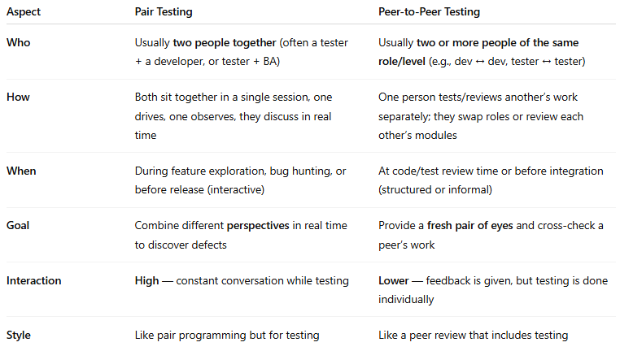
Aspect | Pair Testing | Peer-to-Peer Testing
Who | Usually two people together (often a tester + a developer, or tester + BA) | Usually two or more people of the same role/level (e.g., dev ↔ dev, tester ↔ tester)
How | Both sit together in a single session, one drives, one observes, they discuss in real time | One person tests/reviews another’s work separately; they swap roles or review each other’s modules
When | During feature exploration, bug hunting, or before release (interactive) | At code/test review time or before integration (structured or informal)
Goal | Combine different perspectives in real time to discover defects | Provide a fresh pair of eyes and cross-check a peer’s work
Interaction | High — constant conversation while testing | Lower — feedback is given, but testing is done individually
Style | Like pair programming but for testing | Like a peer review that includes testing

💡 Quick summary:
- Pair testing = two people testing together in the same session.
- Peer-to-peer testing = colleagues testing each other’s work, not necessarily together.

